Arabic Language Basics

Section: L01

Assignment Date: 8/09/2021

Name: Talha Abdullah Punjabi

QUID: 201903446

Unit 6: Drill 25

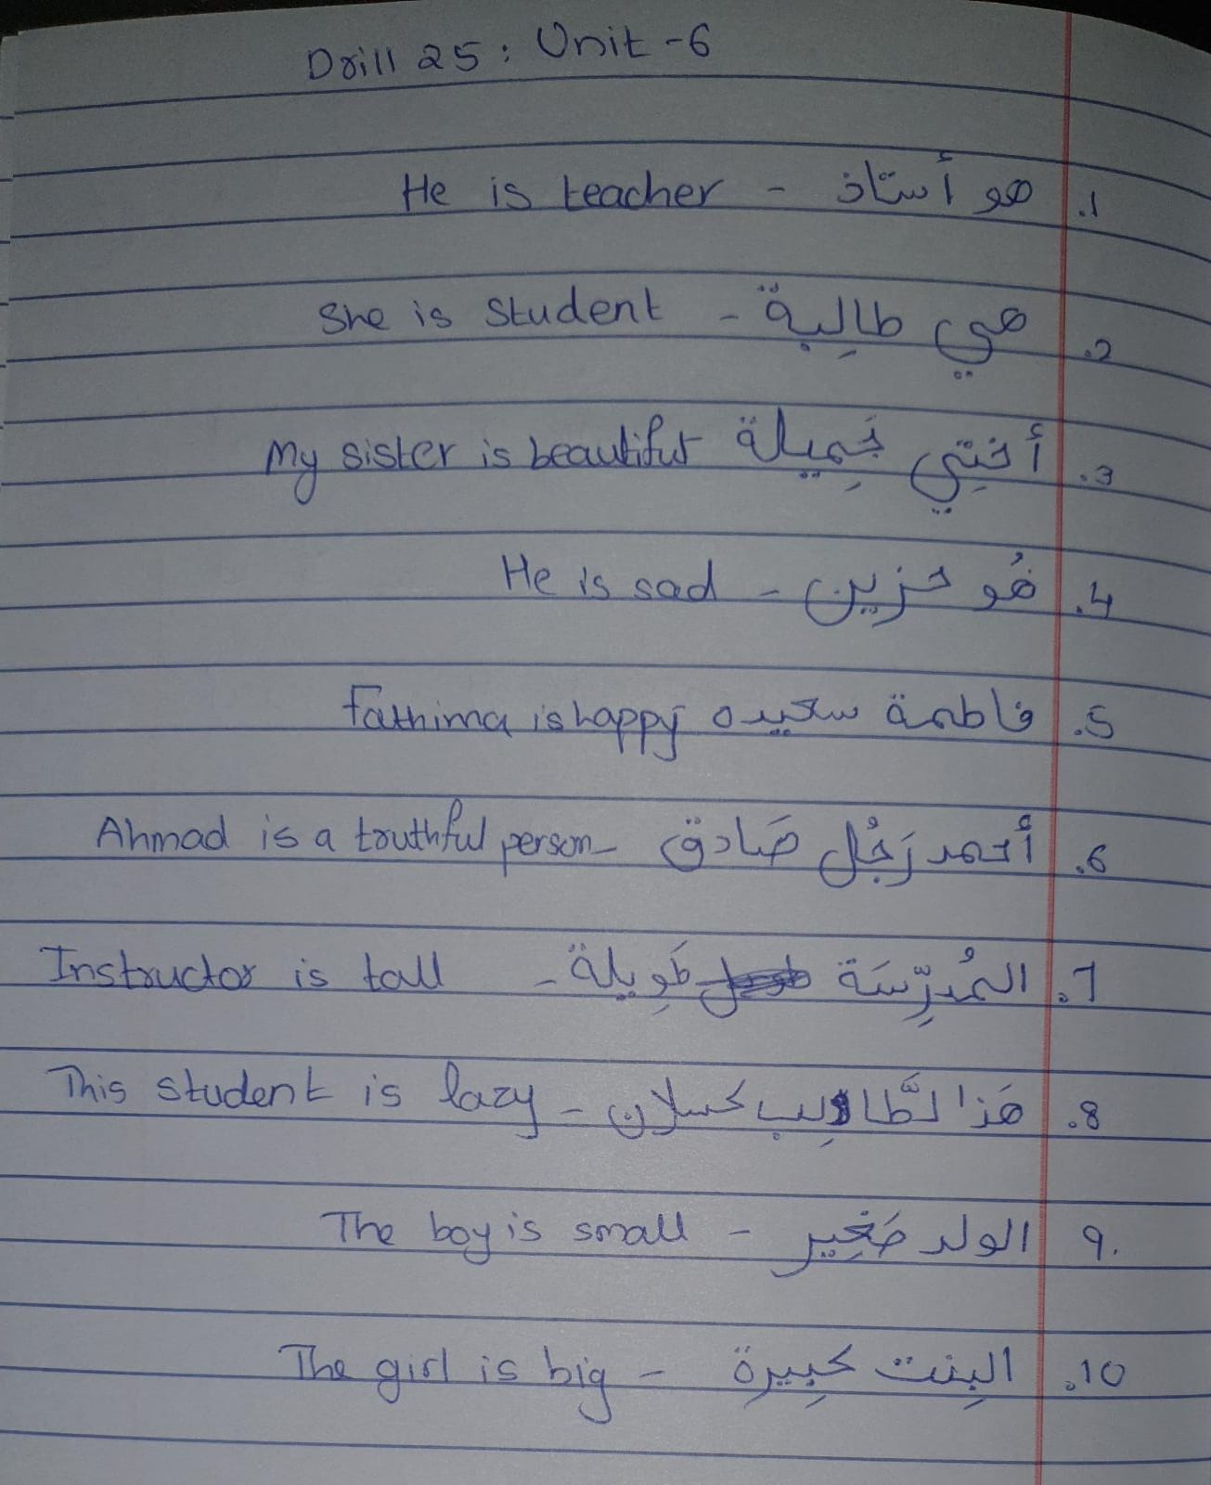

New Letters:

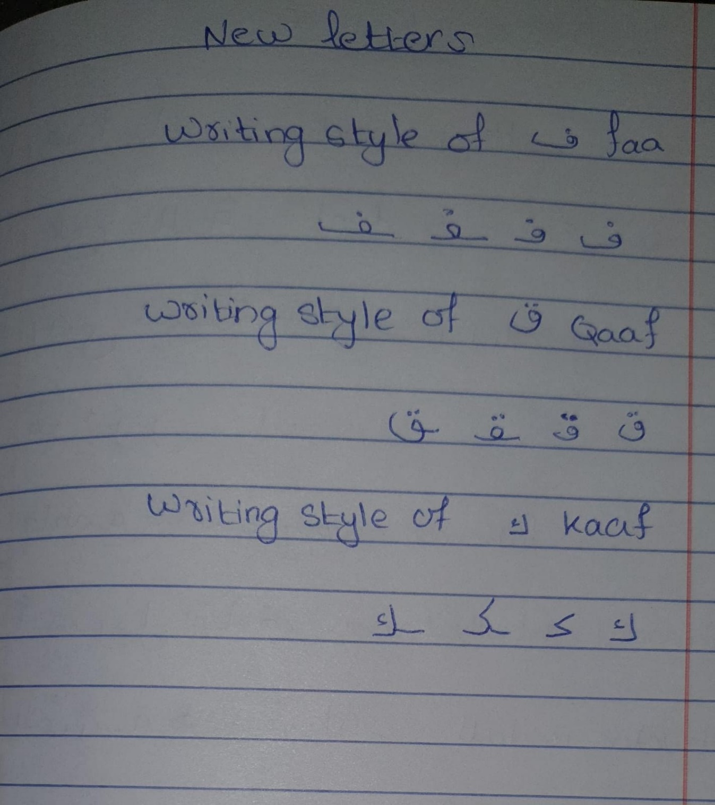

Unit 7: Drill 1

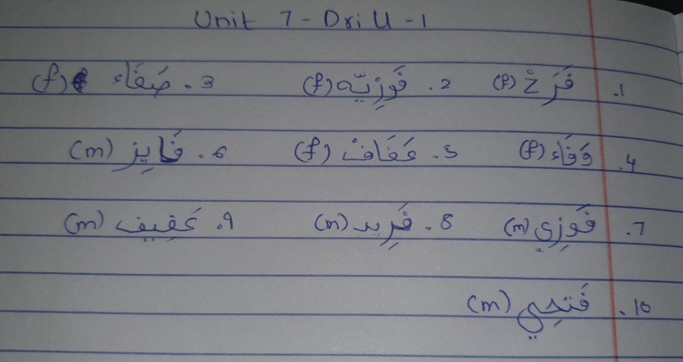

Unit 7: Drill 3

